Haoyuan Qin (001048178)

**Program Structures & Algorithms**

**Fall 2021**

**Assignment No. 2**

* **Task (List down the tasks performed in the Assignment)**
* **Relationship Conclusion: (For ex : z = a * b)**

The more chaos the array is the more time will be spent on sorting. And a reversed array will take a little bit less of time than random array to sort.

sorted: y = 4.9833x + 811578

Random: y = 1.8394x2 - 11280x + 8E+07

Partially sorted: y = 0.2176x2 - 570.04x + 35997

Reversed: y = 1.4962x2 - 18597x + 6E+07

* **Evidence to support the conclusion:**

**Output (Snapshot of Code output in the terminal)**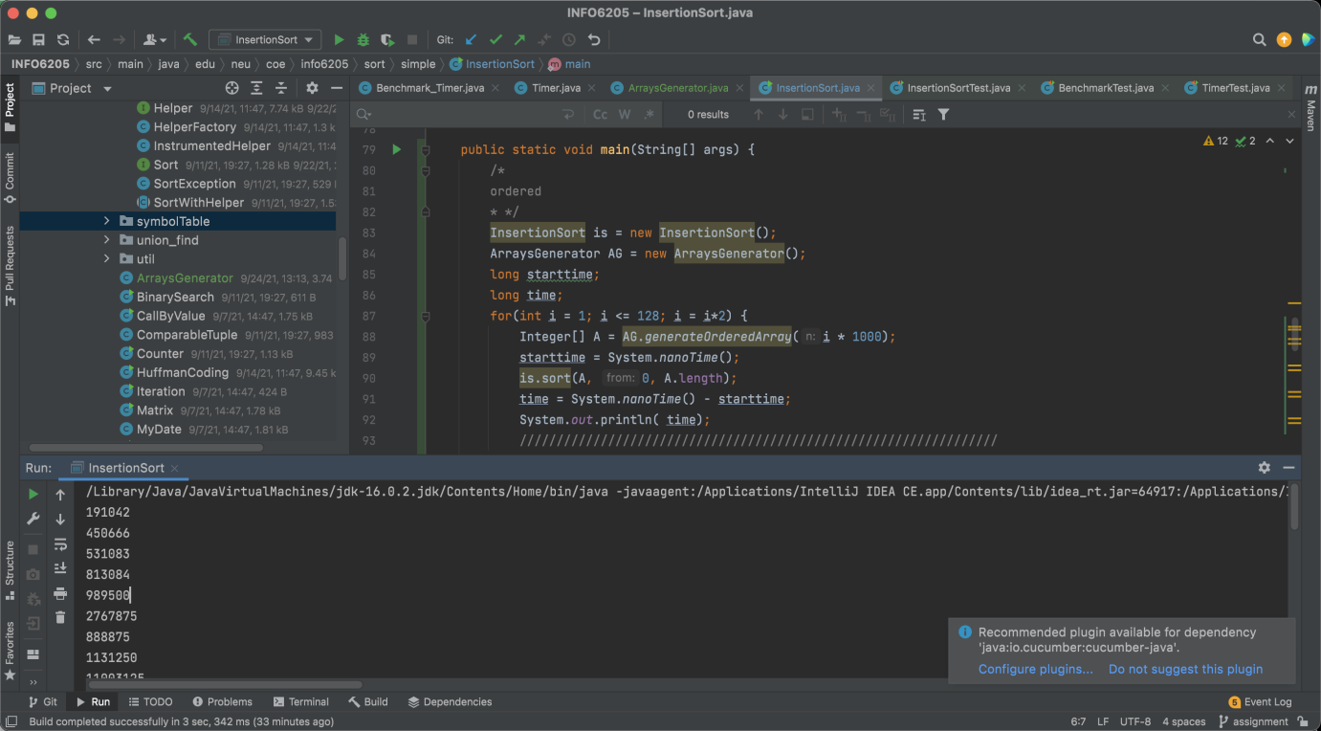

1. **Graphical Representation(Observations from experiments should be tabulated and analyzed by plotting graphs(usually in excel) to arrive on the ßrelationship conclusion)**

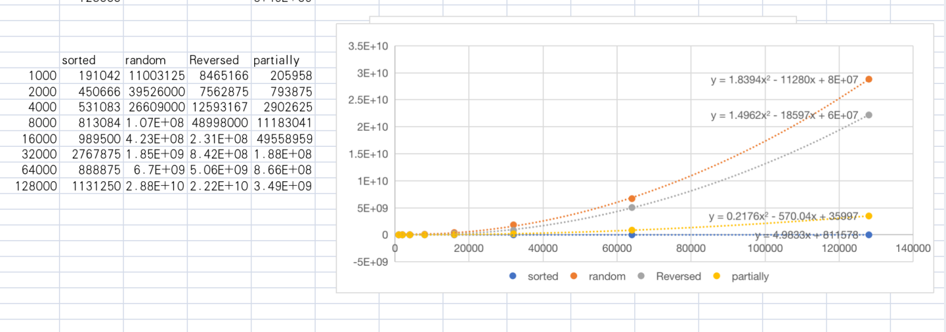

* **Unit tests result:(Snapshot of successful unit test run)**

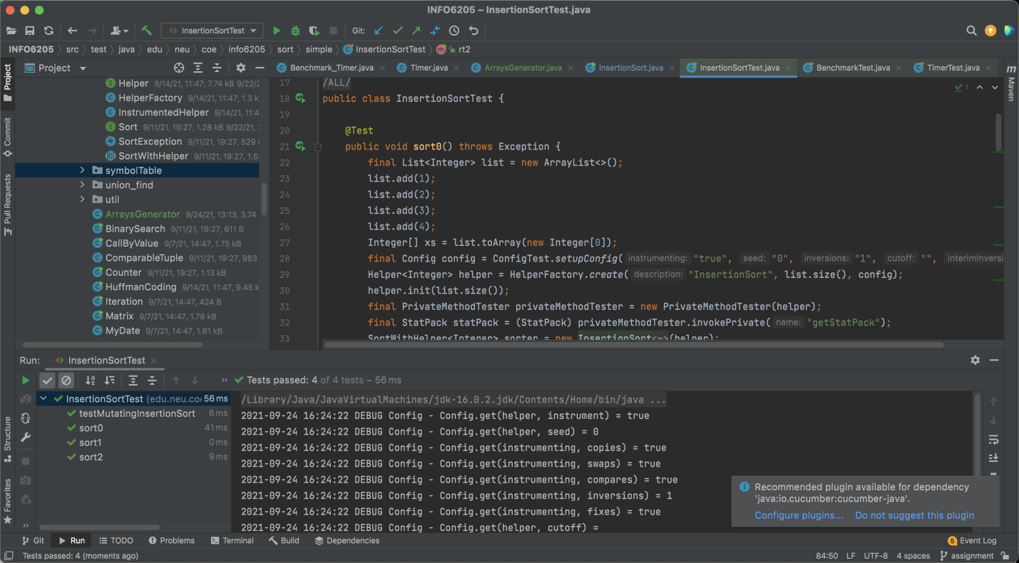

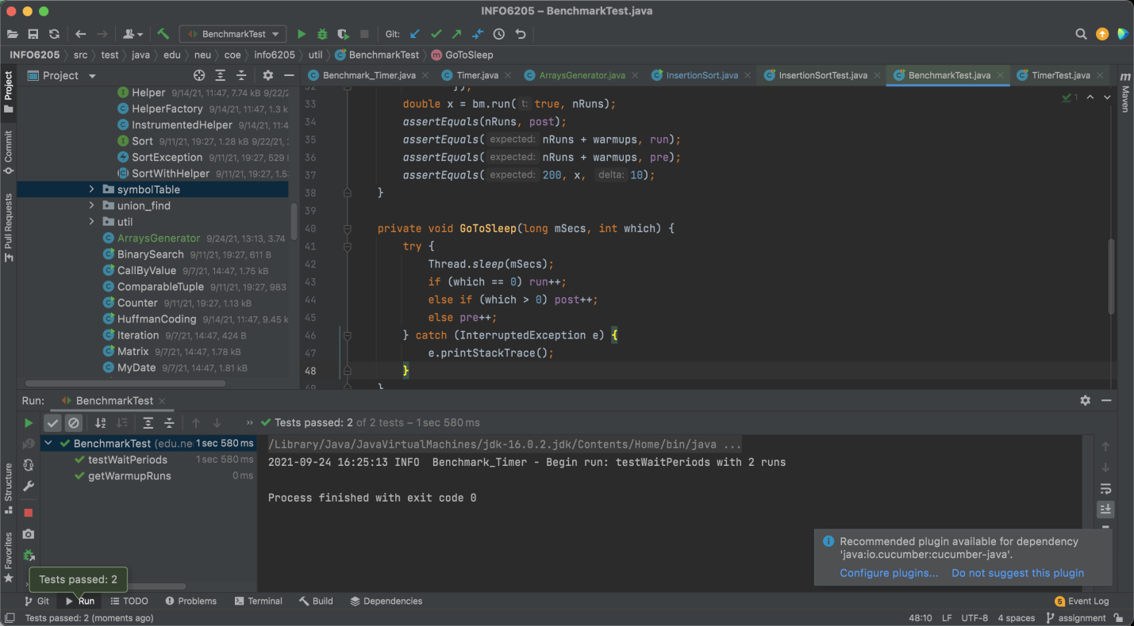

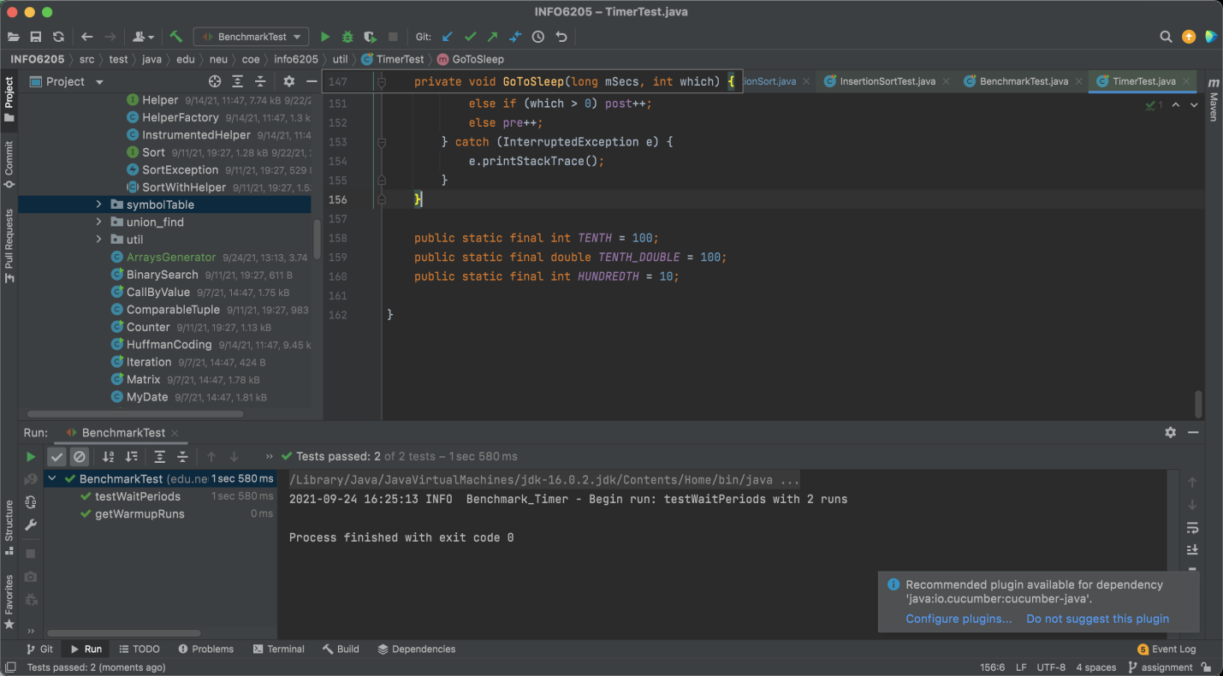

3.Your ****code**** (*RandomWalk.java* plus anything else that you changed or created);

<https://github.com/Jim-Qin/INFO_6205_Assignments.git>